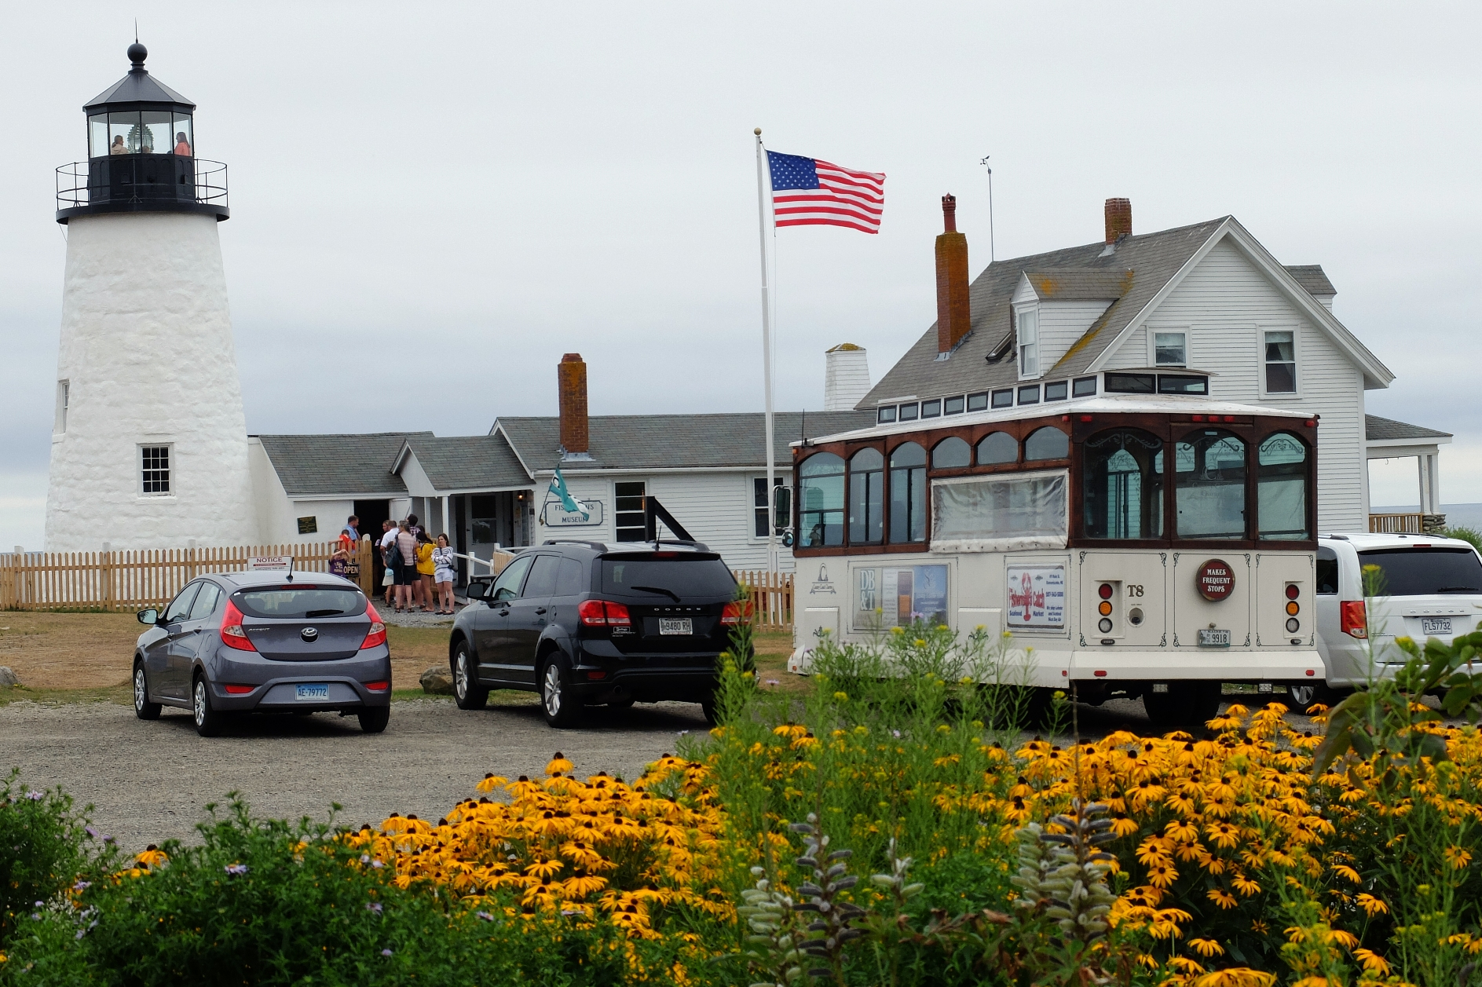

Lincoln County Regional

Planning Commission

STRATEGIC PLAN

2021-2026

EXECUTIVE SUMMARY

aPRIL 22, 2021

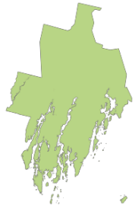
Trolley at Pemaquid, photographed in 2016,
courtesy of Mary Ellen Barnes

About the Regional Planning Commission
The 2021 – 2026 LCRPC Strategic Plan reflects a year of work by the Lincoln County Regional Planning Commission (LCRPC) Board to develop Priorities for the next five years. Going into effect mid-year 2021, this is a guiding document to help LCRPC staff create yearly work plans, formulate budgets, assess progress, and be effective in creating positive change for Lincoln County towns, residents, and businesses.

The LCRPC’s Board is made up of representatives from towns across the County, who are appointed for their local community and land use planning knowledge. Others who provided input to this document and Commission priorities were LCRPC staff members and the County Administrator.

Our Mission is to…
- Provide land use, transportation, economic and community development planning, and related technical assistance to Lincoln County residents and municipal governments.

Our Vision is…
- A strong and sustainable economy, sound land use policies, and a healthy, livable, and safe environment for all.

We Value…
- Providing sound knowledge on myriad topics relevant to Lincoln County.
- Equitable distribution of services across Lincoln County towns.
- Growing connections and networks.
- Building relationships and collaborative partnerships.
- Working towards equitable access for residents to all aspects of community life.

The RPC’s work with towns falls under three major functions: Technical Assistance, Convening, and Communication. Below are services the RPC provides to Lincoln County and its 18 municipalities.

Technical Assistance | Convening | Communication
Provide Planning Assistance  Provide Tools  Provide Connection with State & Federal Programs | Build Knowledge  Build Partnerships | Outreach  Informing  Educate  Track  Share

The Strategic Plan
Strategic Planning Committee Deliverables, July 2020

“The Strategic Plan will meet the needs of Lincoln County and its towns and address their challenges, while employing strategic functions such as convening, communication, and technical assistance.”

“What we are working toward is a high-level vision. It will include goals and challenges for the RPC, contain action steps, and inform a prioritized work plan and outcomes. It is concise, flexible and adaptable, and is not too restrictive.”

Plan Adoption: The Strategic Plan is a tool to describe the Planning Commission’s priorities and desired outcomes while continuing to illustrate the skills and value of the RPC as a County department. It provides a concrete vision for the work the LCRPC is looking to accomplish over a five-year horizon through 2026. The Strategic Plan is a living document. Updates to the Plan are anticipated within its effective dates. The Plan will be presented to the LCRPC Board and County Commissioners for approval.

Implementation: A yearly staff work plan will be developed to ensure action areas for each Priority – Housing, Broadband, Sustainable Economic & Community Development, Transportation, Intergenerational Community Building, and Environmental Sustainability – are being. The yearly work plan is how staff will make the Strategic Plan “actionable” and develop annual budgets.

Measures: Staff will provide updates on their progress to the LCRPC Board on a regular basis. Report outs to the Lincoln County Commissioners will be performed throughout the year, as needed.

A year-end review of the Strategic Plan will assess the success of tasks undertaken, as well as evaluate overall progress in advancing the action areas identified in the Strategic Plan and potentially reprioritizing work for the following year. Progress will be determined using the below measurements:

- What did we do?
- How well did we do it?
- Is anyone better off?
Overarching Considerations for Plan & Process

Consider reasonable staff time across all Priorities for funding research, and do not overextend capacity. We need to know our limitations as it pertains to what the staff can accomplish.

Take into consideration the impact this work will have on all towns across Lincoln County and how communities will benefit, as this is the desire of the County Commissioners and relates to funding.

Do not book entirety of staff time up with tasks. Leave room for unanticipated needs that arise. We need to be flexible with our goals and Priorities, acknowledging that there are many variables and unknowns in the future that will impact them.

Keep climate change as a forefront activity within the Priority of “Environmental Sustainability”. Keep environmental considerations in all decision-making, in addition to just environmental-specific projects.

Apply the principles of “Lifelong Community Building” throughout all Priorities, actions, and work plans.

Work towards greater benefits for all Lincoln County residents.

Lincoln County is home to people of all ages, abilities, and economic levels by increasing access for residents to healthy surroundings, equal justice, economic, and social opportunities.

The LCRPC Priorities and Outcomes in the 5-year Strategic Plan

The Strategic Plan includes six Priorities, and six areas of analysis. Those areas of analysis are Outcomes; Action Areas; Measures; Implementation Mechanisms; Limiting Factors; and Opportunities and Collaborations. These are covered in more detail in the full Strategic Plan document.

The Priorities were vetted by the Strategic Planning Committee. They are sectors of work in which the RPC staff will undertake projects throughout the 5-year plan. The Outcomes are the vision or goal statement for the Priority Area, for example, “An increased number of jobs.”

Priority Category | Outcomes from Implementation of Five-Year Plan
Housing | - Greater understanding of housing needs and assessment of impactful actions.  - Increased availability of housing stock in Lincoln County, with emphasis on affordability and workforce housing, seasonal, homeless, older population, and other demographics not listed here.  - Stronger leadership and increased capacity for housing actions.
Broadband | - Be a recognized leader and source of information and support for broadband in Lincoln County.  - Increased number of residences/businesses with access to broadband internet.  - Increased number of towns with active broadband committees or initiatives.  - Increased technology education, and digital equity and literacy, especially for those disenfranchised by internet and technology progression.
Sustainable Economic & Community Development | - Employment and volunteer opportunities increase.  - Environmental impacts are taken into consideration when economic growth is promoted.  - Public decision making efforts and planning include a broad and diverse participation by businesses, non-profit, civic and service organizations, residents, and local governments.  - The County’s business sector grows and diversifies to include numerous industries, private individuals/corporations, and non-profits, taking into consideration the economic, natural resources, historical, cultural, & societal fabric of Lincoln County.
Transportation | - Lincoln County has diverse resources for healthy and safe mobility options.  - Lincoln County residents are more aware of the transportation options available and the resultant lifestyle changes, including remote working/learning options.  - Lincoln County towns have proper funding for transportation needs.
Intergenerational Community Building | - Lincoln County communities are home to people of all ages through social and cultural connections, health, wellness, and recreation activities, public places, diversified employment and housing, civic engagement, and transportation options.  - Principles of ‘life-long community building’, including those detailed in the 2021 “Age Friendly Maine: Connecting Across Generations” State Plan , are supported to ensure quality of life for all ages in Lincoln County
Environmental Sustainability | - Improved ability across the County to identify, minimize and help mitigate climate change impacts and effects.  - Improved ability of municipalities in Lincoln County to address environmental issues.

These measurement questions are adapted from the Results-Based Accountability™ framework. More information can be found: https://clearimpact.com/results-based-accountability/

